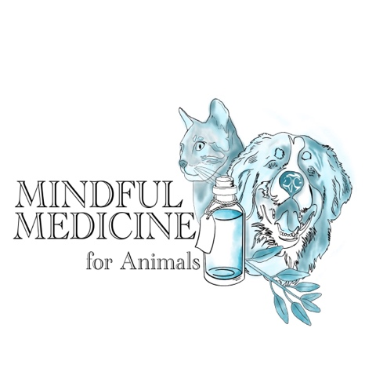
Donna Long IMIM IAAT

Applied Zoopharmacognsy Practitioner
To:

A client of yours has contacted Donna Long – IMIM Applied Zoopharmacognsy Practitioner, requesting an appointment for treatment.

Under the IAAT regulations, veterinary permission is required for any animal currently receiving veterinary medicine, prior to receiving Applied Zoopharmacognsy.
Animals name:  Age:  Species: | Owners Name:  Sex:  Breed:
Veterinary Details

Veterinary Surgeon Name:

Practice:

Address:

Do you give consent for this animal to receive Applied Zoopharmacognsy?  Please provide a summary of the animal’s condition/injury and any further comments. |  | YES NO
Veterinarians Signature: |  | Date:

Please email to donna.long@sky.com or telephone 07968 969730

